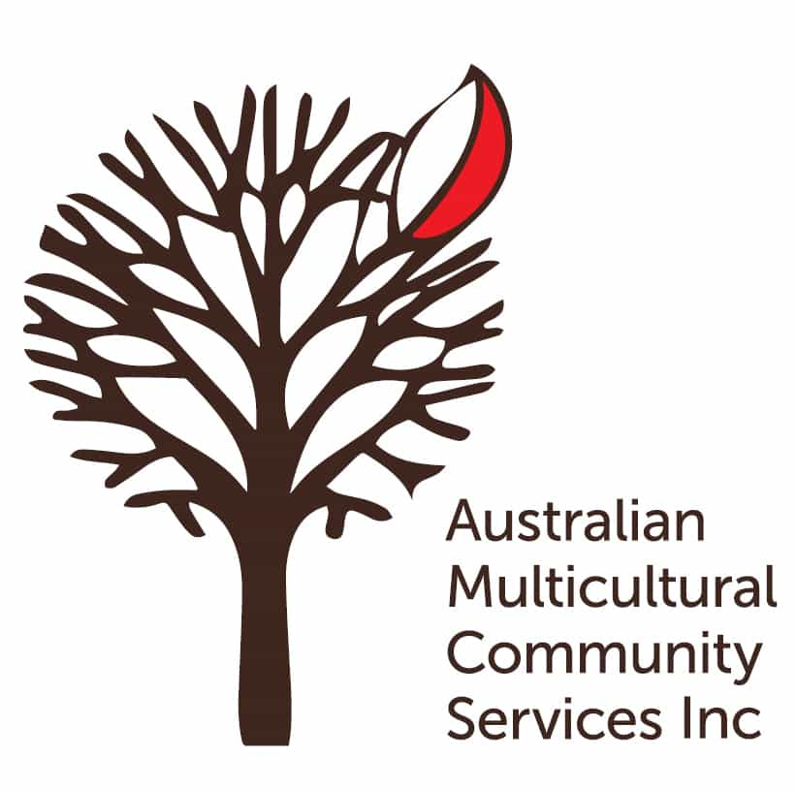
Westvale Community Centre
45 Kings Road, Kings Park 3021
Phone 03 9249 4665
westvale@brimbank.vic.gov.au

Grow Green Garden Talks
Gardening: Self-Sufficient and Healthy Living

Introduction
This program is for seniors from culturally and linguistically diverse backgrounds who want to create a positive change for one self, your family, community or the planet. It aims to bring significant change to your health, habits, practices, lifestyles, and a new sense of community with small, consistent, and practical steps. With climate change disrupting food supplies sending prices of goods and services higher, gardening offers solutions for self-sufficiency and helps the community to live for a more sustainable future.

Outcomes
In this program, you will learn the basics of self-sufficiency which involves how to change your thinking to meet the demands of a self-sufficient lifestyle from personal health through to providing your own basic daily needs. It teaches you practical skills to achieve realistic goals done by community gardeners. Learn to provide yourself and your family with the basic goods and services required to live, and gain a perspective on the broad range of alternative lifestyles that you might lead.

You Will Learn
- To move toward a more sustainable existence
- Explore how to become more self-sufficient
- Save money, live healthier, reduce your environmental footprint
- Learn from people who have done it in their own homes and their community
- Start your journey from garden to plate
- Replicate practices in your own homes, schools, and communities

Practical Skills
You will gain competence in a range of practical skills including building healthy soils, seed saving and raising, planting cycles, waste reduction, composting, cooking and food preserving.

What to Bring
- Comfortable enclosed shoes/boots
- Gardening gloves
- Appropriate weather gear e.g. sunhat
- Pen and paper
- Enthusiasm to learn and get your hands dirty’

What to Wear
Casual comfortable clothing for gardening

Content and Schedule (rough estimate)

- Meet and greet, co-design Week 1
- Planning your food garden Week 2
- Preparing and building healthy soils Week 3
- Plant cycles and identifying seasonal crops Week 4
- Identifying seeds sources and seeds saving Week 5
- Plant varieties Week 6
- Planting and growing crops Week 7
- Managing bugs and pests Week 8
- Managing weeds Week 9
- Edible weeds Week 10
- Abundance: From harvesting to preserving Week11
- Reducing food waste from roots to shoots Week 12
- Composting: Recycle from soil to soil Week 13
- Natural fertilisers Week 14
- Development of cost efficient meals Week 15
- Cooking: From the garden to the kitchen Week 16
- Climate Change and what we can do Week 17
*Monthly expert guest speaker sessions will be scheduled into the program

Course Duration:
February until November 2020
March-November, weekly sessions running from 1.5-2 hours
November onwards, month garden club meet-up

Facilitator: Rowena with monthly guest speakers

This programis delivered by Brimbank City Council in partnership with the Australian Multicultural Community Services (AMCS).

